Satellite-based flood mapping using SAR change detection.
- Abstract
This study aimed to determine the flood extent of the 2022 flooding event in Sindh, Pakistan, using Sentinel-1 Synthetic Aperture Radar (SAR) imagery with VH polarization. As the 2022 floods developed gradually over several weeks due to prolonged monsoon rainfall, the 12-day revisit time of Sentinel-1 enabled effective temporal comparison for change detection analysis. A SAR-based thresholding approach was implemented within Google Earth Engine to delineate inundated areas and estimate flood coverage as a percentage of the total provincial area. The results indicate that approximately 1.3% of Sindh’s area was inundated during the selected peak flood period. The study highlights the utility of cloud-based SAR analysis for rapid flood extent mapping in data-scarce regions.

- Introduction
Flooding has been a global issue for the past few years as climate change is intensifying the weather extremes. Every year, floods affect millions all over the world, disrupting day-to-day life (Amatebelle et al., 2025). The economic losses caused by consistent flooding make nations incapable of recovering in a timely manner and slow to focus on their GDP growth. Large patches of agricultural land are lost to salination resulting from long time exposure of the fields to flood water. These waters can transport nutrients from one region to another, often causing secondary environmental impacts. It is due to these damaging effects that the monitoring of floods is becoming a necessary requirement to keep people and property safe from their worsening impacts.
Ground-based measuring devices are not always a dependable and feasible means to monitor floods, as they can be damaged during a flooding event. Therefore, attention is being shifted to the use of remote sensed data for the delineation of flood extent, which are proven to be more accurate and reliable for the early detection of floods. Additionally, in the last decade, significant progress has been made in near real-time (NRT) flood mapping based on Synthetic Aperture Radar (SAR) satellite data (Martinis et al., 2018). As the sensor operates in the C-band microwave region, it can effectively gather data in heavy precipitation events that are often accompanied by cloud cover. The sensor is mounted atop the Sentinel-1 satellite which has a revisit cycle of 6 days with both satellites 1A and 1B operating.
This study aims to map the flood extent for the Sindh 2022 floods using the Sentinel-1 SAR imagery by developing a reproducible workflow in the Google Earth Engine. A threshold-based approach is applied to determine the flooded area and a sensitivity analysis is performed for the classification threshold. The accuracy of the mapped flood is assessed based on the available reports on the flooding incident.

- Study Area
Sindh is located in southern Pakistan and is characterized by low-lying terrain and the Indus River floodplain, making it highly vulnerable to large-scale inundation. The 2022 flood event in Sindh, Pakistan resulted in approximately 1,600 fatalities and affected an estimated 33 million people nationwide (FLOOD 2022 in Sindh, 2023). The event inundated extensive agricultural areas and caused widespread socio-economic disruption (Najam, 2023). Sindh was selected as the study area due to the large spatial extent and severity of flooding in the province. Furthermore, the event is well captured by Sentinel-1 Synthetic Aperture Radar (SAR) imagery, which enables reliable flood delineation under cloud-covered conditions. The Global Administrative Unit Layers (GAUL) as FAO/GAUL/2015/level2 was used to demarcate Sindh in the Google Earth Engine. The total area of Sindh is calculated to be is 134,892.22 km².

- Data and Methods
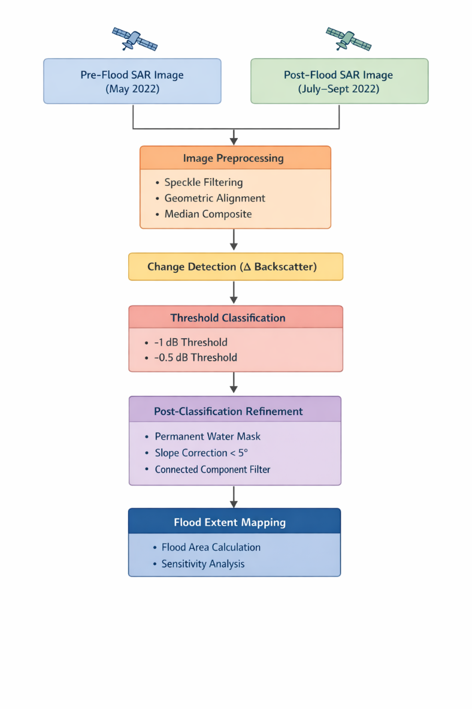
Figure 1. Workflow of Sentinel-1 SAR-based flood detection.

Flooding occurred between 20 June and September 2022 (FLOOD 2022 in Sindh, 2023). As illustrated in Figure 1, the workflow consisted of four primary stages: preprocessing, change detection, classification, and refinement. May 2022 was selected as a pre-flood period so as to represent the baseline surface conditions prior to the onset of rainfall and flooding in Sindh, Pakistan. Post-flooding images were taken from July to the end of September to capture the peak inundation conditions during the 2022 flood event. The temporal interval between the two observations was minimised to reduce the effects of seasonal variability on the results.
SAR data were obtained from the European Space Agency’s Sentinel-1 Ground Range Detected (GRD) archive, which is available through Google Earth Engine as the COPERNICUS/S1_GRD image collection. The satellite operates in the C-band microwave region and provides all-weather, day-and-night imaging capability, making it particularly suitable for flood detection and monitoring in regions frequently affected by cloud cover during extreme weather events (Martinis et al., 2018).
The image collection was filtered to include only Interferometric Wide Swath (IW) acquisition mode scenes, as it provides high spatial resolution for land surface monitoring. To ensure geometric consistency, only images acquired in the descending orbit pass were selected. Only images containing the VH (vertical transmit–horizontal receive) polarization were retained since it detects both flooded and non-flooded areas with greater accuracy (Ashilah et al., 2025). The dataset was further constrained by a filter on metadata of resolution 10 meters. The scenes are limited to the area of interest by bounding them to geometry.
The filtered SAR dataset was temporally separated into pre-flood and post-flood image collections, and median composites were generated to reduce the effects of outliers on the final before and after scenes, as they are clipped to the geometry. The inherent speckle noise in SAR, which is a result of constructive and destructive interference of radar signals, was reduced using a focal median filter in the Google Earth Engine with a kernel of 30-meter radius.
Flood extent was identified using the backscatter change detection approach between the after and before image scenes. As open water surfaces typically produce lower backscatter values due to specular reflection of radar signals away from the sensor, resulting in a measurable decrease in signal intensity (Martinis et al., 2018), the flood extent was detected by computing the difference between post-flood and pre-flood backscatter values. A threshold-based classification was applied to the difference image such that the pixels exhibiting a backscatter reduction of less than -2 dB were classified as potential flooded areas. When the threshold was relaxed to -1 it showed high difference in the percentage increase of the total flooded area. -2 db is taken as a conservative value based on the literature review (Hlaváčová et al., 2021). The threshold is selected based on the histogram and sensitivity analysis.
The initial flood map was further refined through several post-classification corrections to reduce false positives. Permanent water bodies were removed to ensure that only temporary floodwater was mapped using the NASA Global Surface Water dataset, as persistent inundation exceeding six months per year was excluded from the flood extent. Moreover, water does not accumulate on steep slopes; therefore, another correction for the terrain was applied to include only those regions where the slope is less than 5°. Finally, flood detection was improved by applying a connected pixel count filter to remove isolated noise being classified as flood.

- Results
The SAR backscatter difference approach successfully delineated inundated areas across the Sindh Province following the 2022 monsoon floods. Using the -1dB threshold, the flood area was calculated to be approximately 1.3% of the provincial area, corresponding to roughly 1,730 km². When the threshold was relaxed to -1 dB, the estimated inundation increased to 2,806 km² (≈2.1%), indicating higher sensitivity to threshold selection. The -2 dB threshold was therefore retained for final estimation, as it provides a conservative delineation focused on strong backscatter reduction characteristics of open water surfaces in VH polarization.
Moreover, a sensitivity analysis was performed using the same thresholds on flood images with no mask for permanent water, slope or connected pixel count filter. It was found that the area with a -1 dB threshold is 21,517.89 km² (15%) and that for -2 dB is 12,548.25 km² (9.3%) indicating the presence of false positives.

- Discussion
Independent assessment of the 2022 floods in Pakistan reported that up to 18% (Faisal, 2022) of the land was affected at peak inundation which is line with the area calculated before refinement masking where the flood coverage was at 15% of the total land area.
However, when refinement masks were applied to the initial flood extent map, the computed area drastically reduced to 1.3% of the region. The reason for this discrepancy is permanent water masking (based on the Joint Research Centre Global Surface Water dataset) and slope masking (using SRTM DEM data from the United States Geological Survey) which reduced overestimation.
Therefore, the results presented here likely represent persistent and high-confidence inundation, rather than maximum transient flood extent.

- Limitations
Several limitations should be acknowledged:
- Lack of ground-truth validation data
- Potential underestimation due to temporal averaging
- Inability of VH-only classification to fully distinguish between shallow water and saturated soil (Martinis et al., 2018)
- Dependence on fixed threshold rather than adaptive thresholding (e.g., Otsu method)
Future work could incorporate multi-polarization analysis (VV + VH) or integration with optical datasets where cloud-free imagery is available.

- Conclusion
This study shows that Sentinel-1 Synthetic Aperture Radar (SAR) imagery is a reliable means to delineate flood extent using change detection in the Google Earth Engine. The methodology successfully identified extent of flooding for the Sindh 2022 floods in Pakistan giving a coverage of 1.3% of the provincial area. This relatively conservative estimate corresponds to the application of a strict backscatter thresholding and refinement masks to the region of interests to minimize overestimation. The method can be refined further by using an automated thresholding approach and validation against ground dataset. Overall, the study highlights the utility of cloud-based SAR analysis for rapid flood assessment in data-scarce regions.

- References

Amatebelle, C.E., Owolabi, S.T., Ogundeji, A.A. and Okolie, C.C., 2025. A systematic analysis of remote sensing and geographic information system applications for flood disaster risk management. Journal of Spatial Science, 70(3), pp.441-467.

Ashilah, H. and Lasminto, U., 2025. Enhancing Flood Detection in Surabaya: A Comparative Study of VV and VH Polarizations with Sentinel-1 Data. Journal of Civil Engineering, 40(1), p.89.

Faisal M. Qamer. (2022, September 09). Impact of the 2022 floods on agriculture in Pakistan’s Sindh Province. Servir. https://servir.icimod.org/news/impact-of-the-2022-floods-on-agriculture-in-pakistans-sindh-province

FLOOD 2022 in Sindh, 2023. Provincial Disaster Management Authority Rehabilitation Department Government of Sindh.
Hlaváčová, I., Kačmařík, M., Lazecký, M., Struhár, J. and Rapant, P., 2021. Automatic open water flood detection from Sentinel-1 multi-temporal imagery. Water, 13(23), p.3392.

Martinis, S., Plank, S. and Ćwik, K., 2018. The use of Sentinel-1 time-series data to improve flood monitoring in arid areas. Remote Sensing, 10(4), p.583.

Najam U Din, 2023. The 2022 Floods and Challenges for Vulnerable Communities in Sindh. The Knowledge Forum.

- Appendix A
Key Code Snippets
  - Filtering
var imageCollection = ee.ImageCollection("COPERNICUS/S1_GRD")
.filter(ee.Filter.eq("instrumentMode","IW"))
.filter(ee.Filter.eq("orbitProperties_pass","DESCENDING"))
.filter(ee.Filter.eq("resolution_meters", 10))
.filter(ee.Filter.listContains("transmitterReceiverPolarisation","VH"))
.filterBounds(geometry)
.select("VH");

var beforeCollection =imageCollection.filter(ee.Filter.date(beforeStart, beforeEnd)).median().clip(geometry);

var afterCollection =imageCollection.filter(ee.Filter.date(afterStart, afterEnd))
.median().clip(geometry);

  - Difference
var difference = after_s.subtract(before_s);

  - Threshold Classification
var floodExtent_1 = difference.lt(-1).selfMask().rename("Water"); //conservative

var floodExtent_05 = difference.lt(-0.5).selfMask().rename("Water05"); //less strict

  - Area Computation
var floodedArea_1 = floodExtent_1.multiply(ee.Image.pixelArea())
.reduceRegion({
reducer:ee.Reducer.sum(),
geometry: geometry,
scale: 10,
bestEffort: true
});

var floodAreaSqKm_1 = ee.Number(floodedArea_1.get("Water")).divide(1e6);

print("Flood Area_1 SqKm:", floodAreaSqKm_1);

var floodExtent_05 = floodExtent_05.multiply(ee.Image.pixelArea())
.reduceRegion({
reducer:ee.Reducer.sum(),
geometry: geometry,
scale: 10,
bestEffort: true
});

var floodAreaSqKm_05 = ee.Number(floodExtent_05.get("Water05")).divide(1e6);

print("Flood Area_05 SqKm:", floodAreaSqKm_05);

var floodedArea = flooded.multiply(ee.Image.pixelArea())
.reduceRegion({
reducer:ee.Reducer.sum(),
geometry: geometry,
scale: 10,
bestEffort: true
});

var floodAreaSqKm = ee.Number(floodedArea.get("Water")).divide(1e6);

print("Flood Area SqKm:", floodAreaSqKm);

- Appendix B
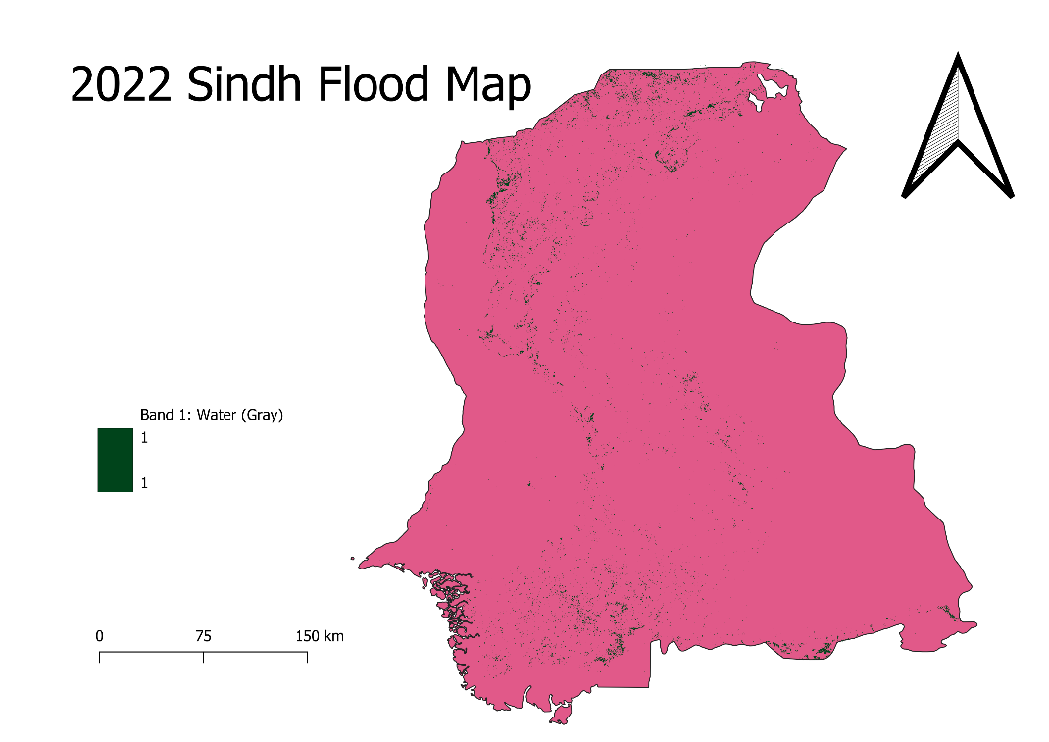
Figure 2. Sindh Flood Map After Applying Post-Classification Refinements.

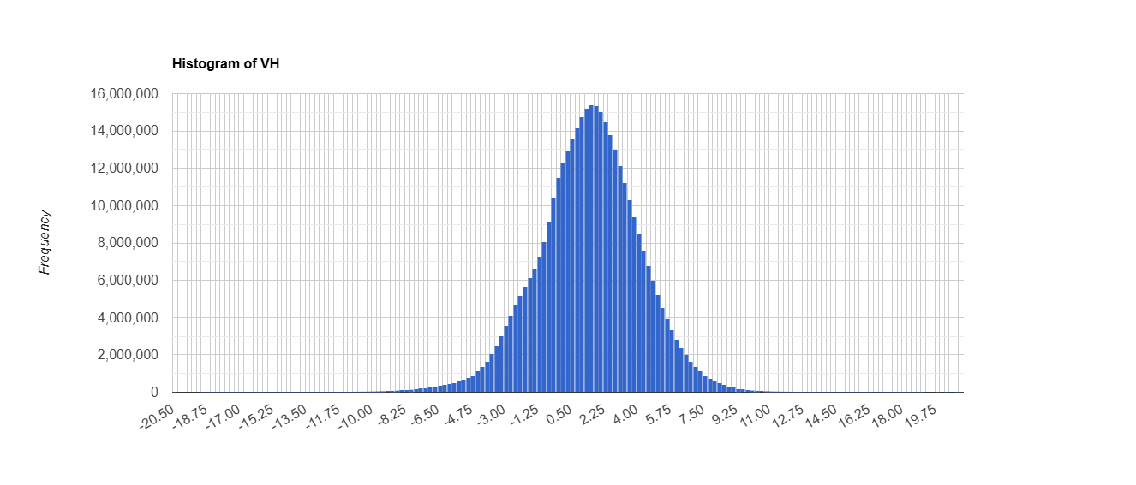
Figure 3. Histogram for Threshold Classification.

